**CDS – programming lab all implementations and outputs**

( Section-D1) By Samuel Priyatam

15th September 2023

#include<stdio.h>

int main(){

printf("Welcome to vssut, Burla");

return 0;

}

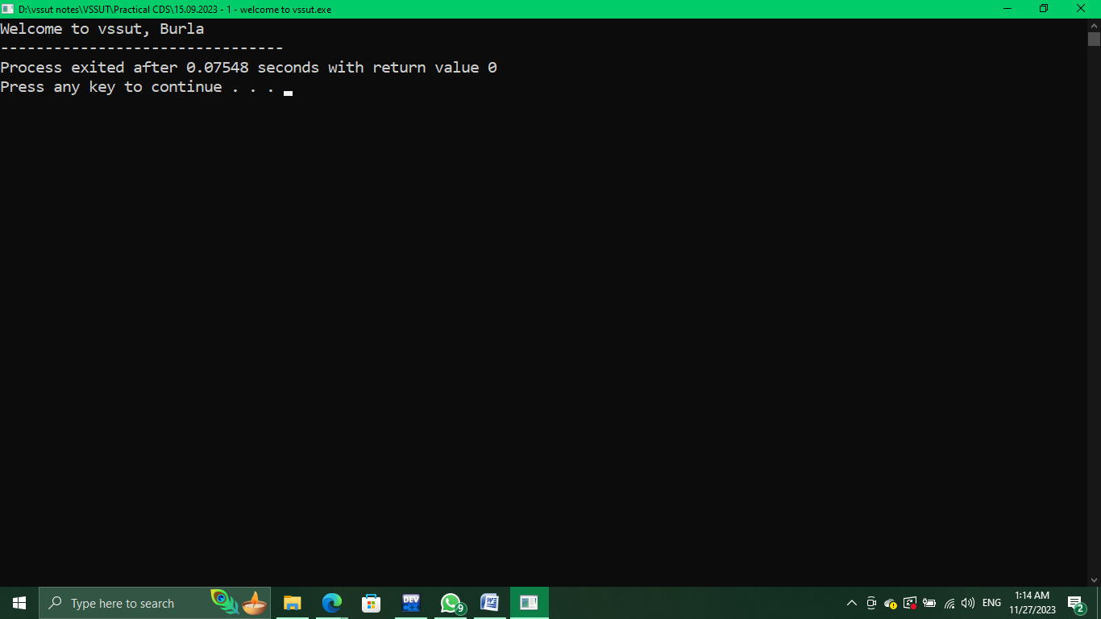

/*WAP to enter details of a student like name, branch,

regd no, course and print them */

#include <stdio.h>

int main(){

char name[30],course[10],branch[5];

unsigned long int regno;

printf("Enter student details \nEnter your name :");

gets(name);

printf("Enter your course :");

gets(course);

printf("Enter your branch :");

gets(branch);

printf("Enter your registration number :");

scanf("%ld",&regno);

printf("\nThe student details are : \nName : %s\nCourse : %s\nBranch : %s \nRegistration No. : %u",name,course,branch,regno);

return 0;

}

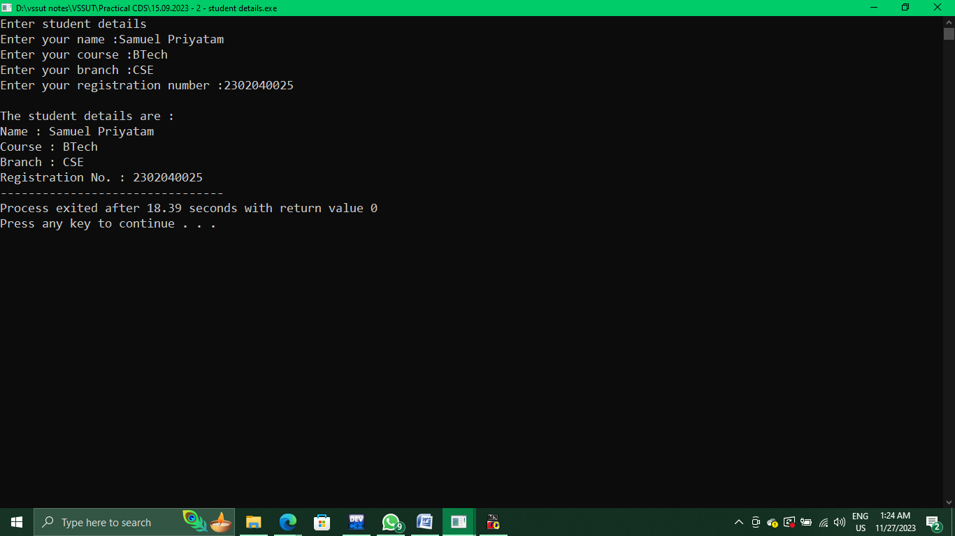

//WAP to enter 2 numbers and perform all arithematic operations on it

#include <stdio.h>

int main(){

int a,b;

printf("Enter 2 numbers :");

scanf("%d %d",&a,&b);

if (a<b){

int temp=a;a=b;b=temp;

}

float quoteint = (float)a/b;//here type casting is used to get exact float value after division

printf("The sum of the numbers is : %d",a+b);

printf("\nThe difference of the numbers is : %d",a-b);

printf("\nThe product of the numbers is : %d",a*b);

printf("\nThe quoteint of the two numbers is : %f ",quoteint);

printf("\nThe remainder of the two numbers is : %d ",a%b);

return 0;

}

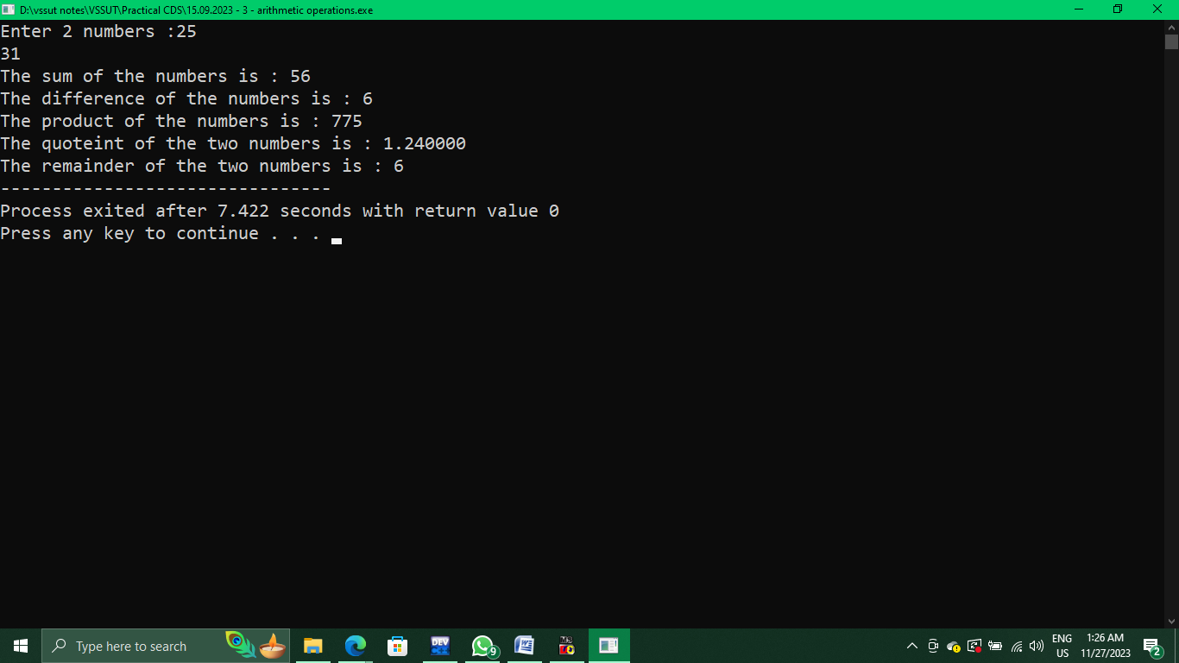

// wap to perform arithematic operations after storing the answers in variables

#include <stdio.h>

int main(){

int a,b;

printf("Enter 2 numbers :");

scanf("%d %d",&a,&b);

if (a<b){

int temp=a;a=b;b=temp;

}

float quoteint = (float)a/b;//here type casting is used to get exact float value after division

int sum = a+b;

int product = a*b;

int difference = a-b;

int remainder = a%b;

printf("The sum of the numbers is : %d",sum);

printf("\nThe difference of the numbers is : %d ",difference);

printf("\nThe product of the numbers is : %d",product);

printf("\nThe quoteint of the two numbers is : %f ",quoteint);

printf("\nThe remainder of the two numbers is : %d ",remainder);

return 0;

}

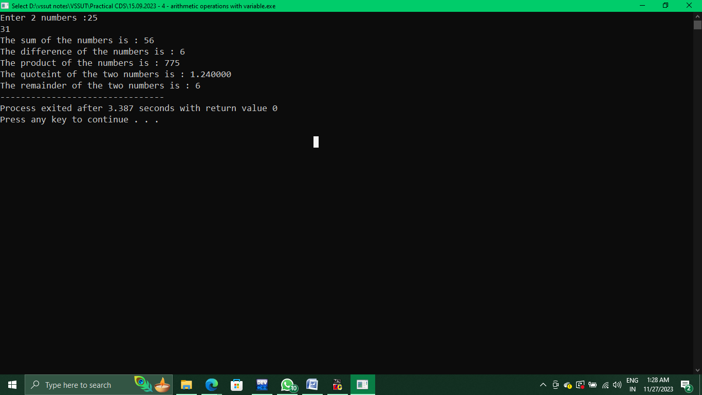

29th September 2023

//wap to calculate simple interest and compound interest

#include<stdio.h>

#include<math.h>

void main(){

float p,r,t;

printf("Enter principal, rate and time :");

scanf("%f%f%f",&p,&r,&t);

float si=(float)p*r*t/100;

float ci =p*pow(1+(float)(r/100),t)-p; //instead of pow func, we can use a^b

printf("The simple interest on the given amount and interest rate is : %f\n",si);

printf("The compound interest on the given amount and interest rate is : %f\n",ci);

}

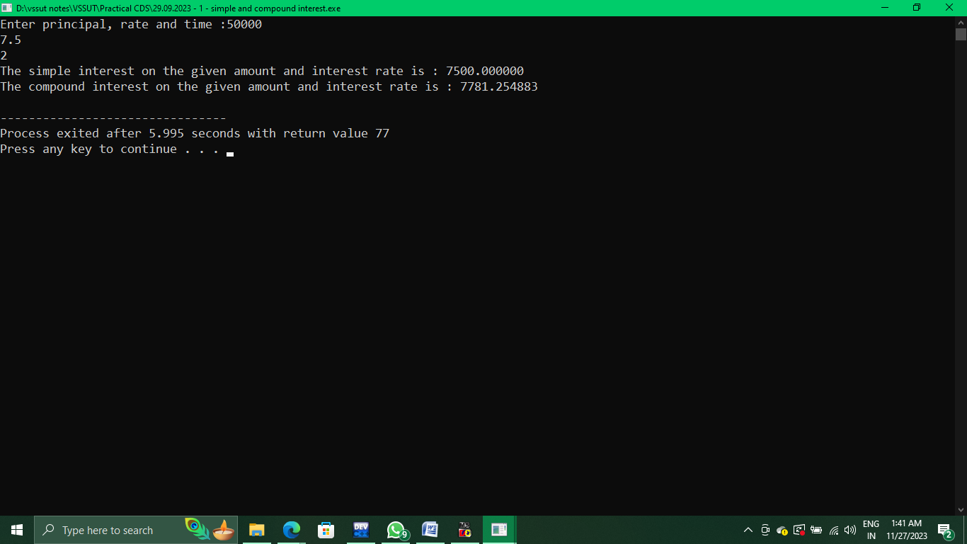

//WAP to demonstrate logical operators : && and, || or

#include <stdio.h>

void main(){

int x,y;

printf("Enter 2 numbers :");

scanf("%d%d",&x,&y);

printf("Logical AND operator :\n%d && %d\n",x,y);

if (x&&y){

printf("AND condition True"); }

else {

printf("AND condition False");}

printf("\nLogical OR operator :\n%d && %d\n",x,y);

if (x||y){

printf("OR condition True");}

else {

printf("OR condition False");}

printf("\nLogical NOT operator\n");

int a=0,b=1;

printf("NOT of 0 is : %d",!a);

printf("\nNOT of 1 is : %d",!b);

}

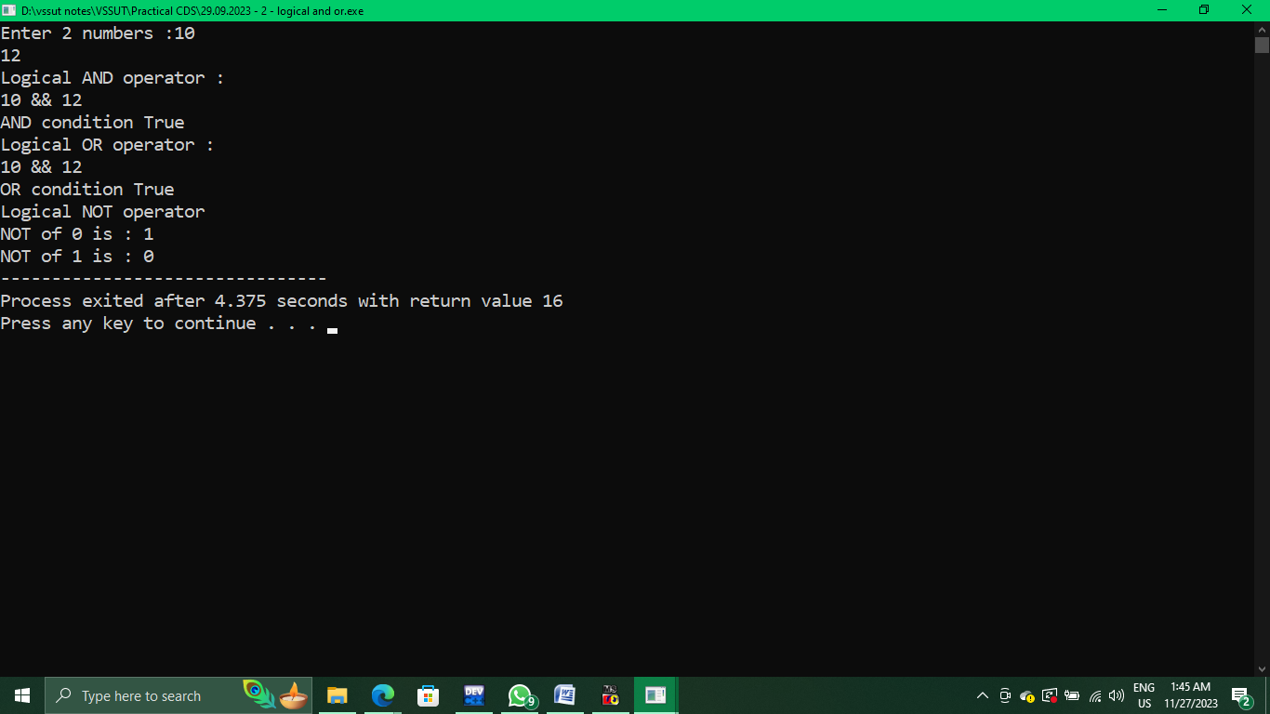

/*WAP to calculate salary of a employee given - basic pay,

HRA - 5% of bp,DA - 20% OF bp, travel allowance - 12% of da

and total salary = BP+ HRA+TA+DA */

#include <stdio.h>

void main(){

int bp;

float sal,da,hra,ta;

printf("Enter the basic pay of the employee :");

scanf("%d",&bp);

da=0.2*bp;

hra=0.05*bp;

ta=0.12*da;

sal = bp+hra+da+ta;

printf("The total salary of the employee is : %f",sal);

}

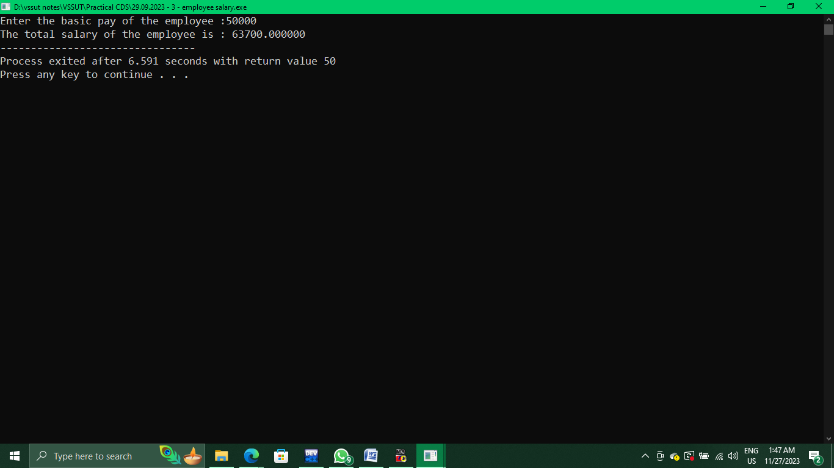

//WAP to calculate the sum of n natural numbers using for loop

#include <stdio.h>

void main(){

int n,sum;

printf("Enter the value n upto which sum is to be calculated :");

scanf("%d",&n);

sum=(int)(n*(n+1)/2);

printf("The sum of first %d natural numbers is : %d",n,sum);

}

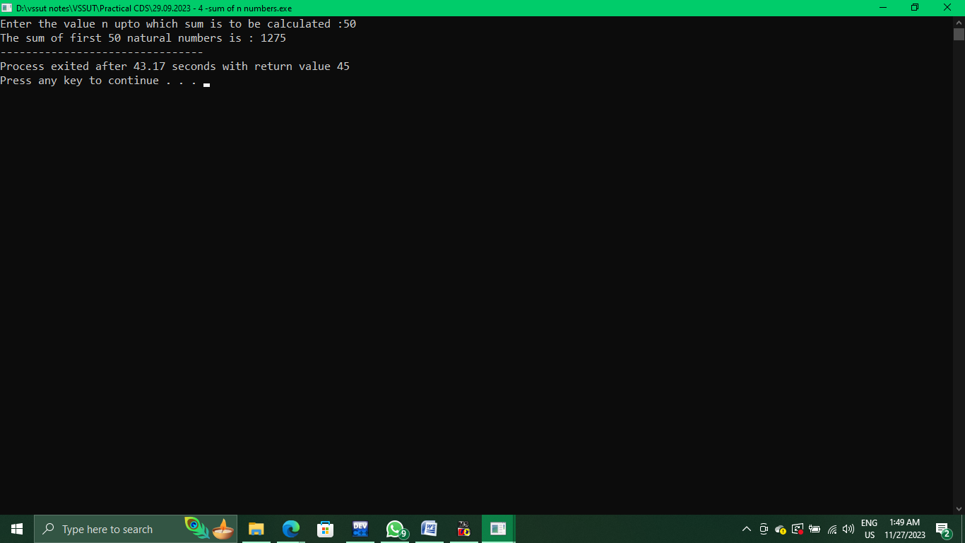

6th October 2023

/*WAP in C to enter the marks of student in 4 subjects, then calculate the total aggregate percentage

and display grade obtained by the student : O - above 90%, A+ - Above 80%, A - Above 70%, B+ - Above 60%,

B - Above 50%, C - Above 40%, F (fail) - Below 40% */

#include <stdio.h>

void main(){

int p,c,m,cs,ful;

printf("Enter full marks in all 4 subjects combined :");

scanf("%d",&ful);

printf("Enter marks obtained by student in physics :");

scanf("%d",&p);

printf("Enter marks obtained in chemistry :");

scanf("%d",&c);

printf("Enter marks obtained in maths : ");

scanf("%d",&m);

printf("Enter marks obtained in computer science :");

scanf("%d",&cs);

float per=(float)((p+c+m+cs)*100/ful);

printf("The students grade is :");

if (per>=90)

printf("O - Outstanding!");

else if(per>=80)

printf("A+");

else if (per>=70)

printf("A");

else if (per>=60)

printf("B+");

else if (per>=50)

printf("B");

else if (per>=40)

printf("C");

else

printf("F - Failed");

}

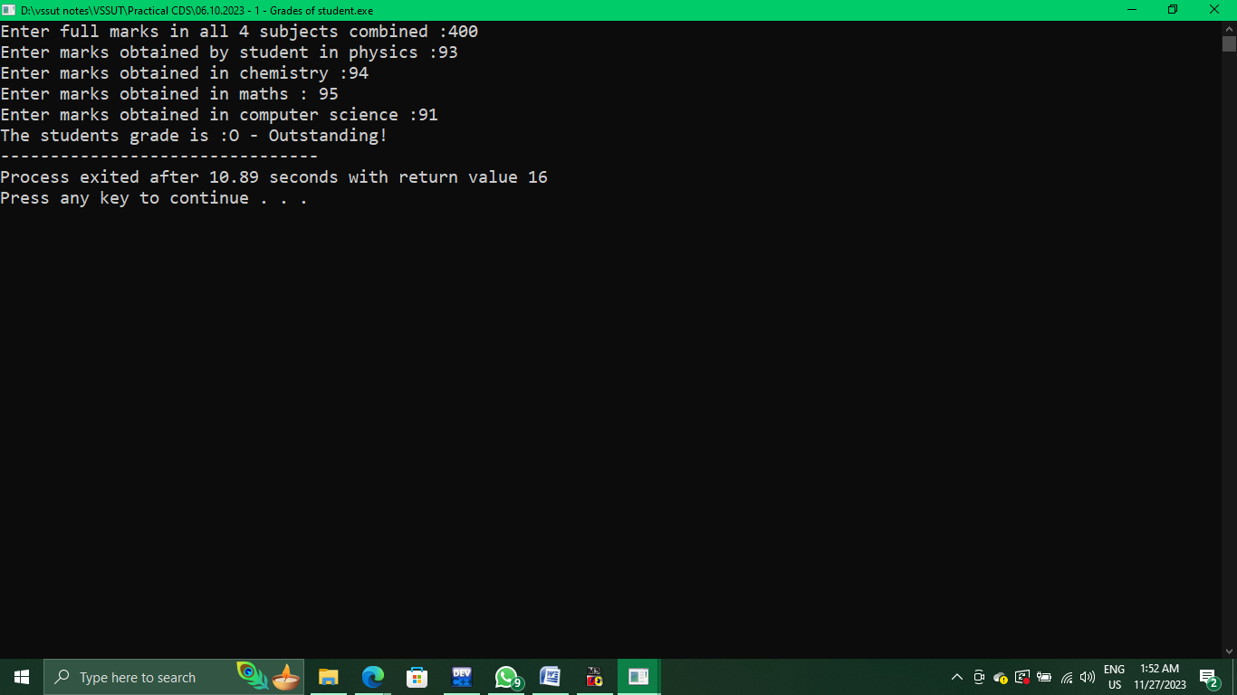

/* WAP to enter a number from 1 to 7 and display the corresponding

day of the week using switch case statement */

#include <stdio.h>

void main(){

int i;

printf("Enter a number between 1 and 7 :");

scanf("%d",&i);

printf("The corresponding day of the week is :");

switch(i){

case 1:

printf("Sunday"); break;

case 2:

printf("Monday"); break;

case 3:

printf("Tuesday"); break;

case 4:

printf("Wednesday"); break;

case 5:

printf("Thursday"); break;

case 6:

printf("Friday"); break;

case 7:

printf("Saturday"); break;

default :

printf("The value entered is greater than 7");

}

}

